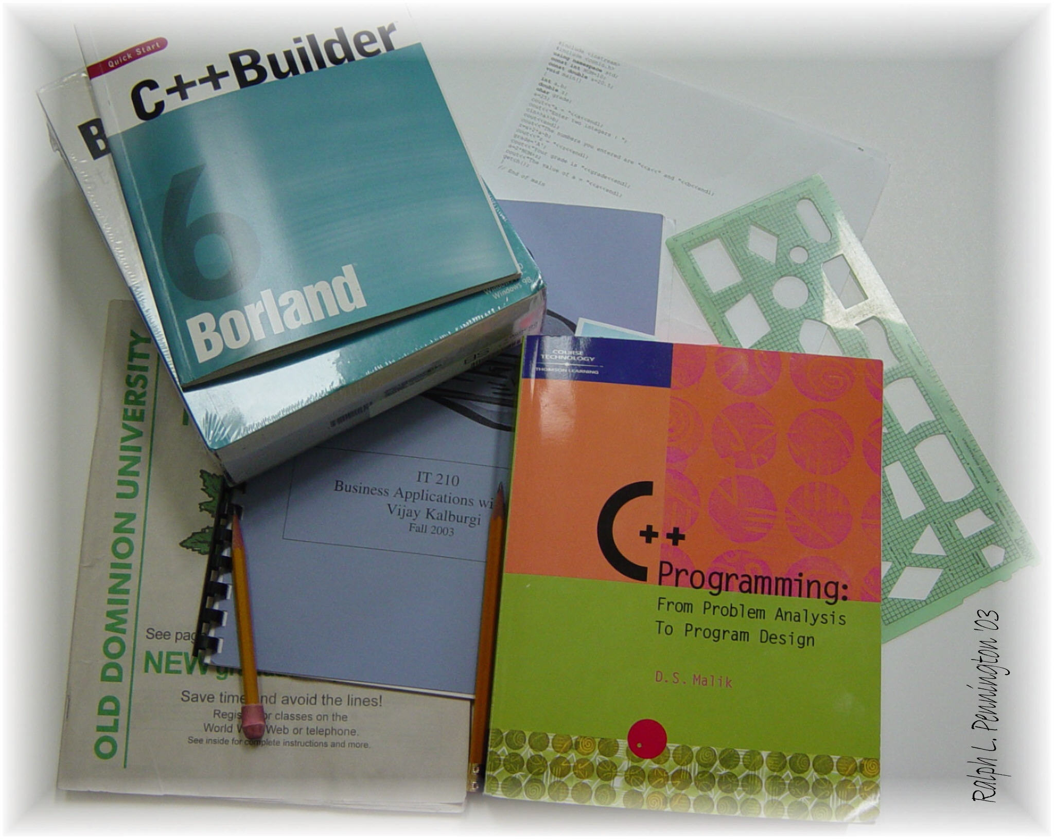

Michael Ragsdale
IT210 Business Applications with C++
TR 11:00 – 12:15 PM
Instructor: Vijay Kalburgi

Program Assignment 1

Mass & Density Calculator
Credit Card Balance Calculator
Fall 2014

Michael Ragsdale

00978282

Mass & Density Calculator
Credit Card Balance Calculator

Monday, September 15, 2014

